**POLYTECHNIC UNIVERSITY OF THE PHILIPPINES**

San Juan Campus

Ortega corner Mabini Street, Barangay Addition Hills, San Juan City

**CONTRACT MONITORING SYSTEM**

An Undergraduate Proposal Documentation

Presented to

**Mr. Elias Austria**

In Partial Fulfillment of the Requirements for

INTE 4213

**Capstone Project**

By:

Alonzo, Celeena C.

Beltran, Eunice S.

Escobiñas, Carmina Z.

Pabatao, Benedict S.

Remollo, Bernie Z.

Sarabia, Chester James J.

**TABLE OF CONTENTS**

**CHAPTER 1: PROJECT DEFINITION**

**1.1 Introduction…………………………………………………………………………….**

**1.2 Business Case…………………………………………………………………………**

1.2.1 Background of the Organization**………………………………………**

1.2.2 Project Overview**…………………………………………………..**

1.2.3 Project Constraint**…………………………………………………………………**

1.2.4 Project Assumptions**………………………………………………………………**

**1.3. Scope and Limitation……………………………………………………………….**

**1.4. Methods Used in the Study……………………………………………………...**

**CHAPTER 2: FUNCTIONAL SPECIFICATION REPORT**

**2.1 Data Requirements…………………………………………………………………..**

2.1.1 Forms**……………………………………………………………………………...**

2.1.1.1 List of Forms**……………………………………………………………….**

2.1.1.2 Layout of Forms**……………………………………………………………**

2.1.2 Reports**……………………………………………………………………………**

2.1.2.1 List of Reports**……………………………………………………………..**

2.1.2.2 Layout of Reports**…………………………………………………………**

**2.2 Policies and Procedures………………………………………………………….**

2.2.1 Procedures**……………………………………………………………………**

2.2.1.1 Context Diagram**…………………………………………………………**

2.2.1.2 Level 1 DFD**……………………………………………………………..**

2.2.2 Policies**……………………………………………………………………….**

2.2.2.1 Business Requirements**………………………………………………..**

2.2.2.2 Business Policies**………………………………………………………..**

**2.3 Problem Analysis…………………………………………………………………..**

2.3.1 Fishbone**……………………………………………………………………..**

2.3.2 Problems and Requirements**……………………………………...**

2.3.3 Conclusion**…………………………………………………………………..**

2.3.4 Recommendation**…………………………………………………………..**

**CHAPTER 3: PROPOSED SYSTEM DEFINITION**  
 **3.1 Requirements-Features Matrix……………………………………………………**

**3.2 Functional Specification……………………………………………………………**

3.2.1 System Boundaries**……………………………………………………………**

3.2.2 System Use Case Diagram**…………………………………………………...**

3.2.3 Detailed per Use Case**………………………………………………………..**

3.3.4 Use Case Description**…………………………………………………………**

**3.3 Technical Specification……………………………………………………………**

3.3.1. Class Diagram**……………………………………………………………….**

3.3.1.1 List of Classes**………………………………………………………..**  
 3.3.2. Activity Diagram**……………………………………………………………..**

3.3.3. Database Design**……………………………………………………………**

3.3.2.1 Database Schema**………………………………………………….**

3.3.2.2 Data Dictionary**………………………………………………………**

**APPENDICES**

* Sample of Forms**………………………………………………………..**
* Sample of Reports**………………………………………………………**
* Sample Questionnaire**………………………………………………….**
* Likert Scale**………………………………………………………………**

**CHAPTER I**

**Project Definition**

* 1. **Introduction**

Over the years, a lot of things have changed. Whether in terms of transportation, communication and even in infrastructures. Everything has been automated to make our lives easier and to utilize a quality output. Hence, innovative excellence has advanced throughout the years. So, with this kind of modernization to human lives, the developers would like to take the given impetus to surpass the limitations of the result. The developers will provide an invariable system that will improve the quality of work and productivity of the company respectively in the monitoring of the construction. In order to comply with this system, the developers will strive to achieve good results.

**1.2 Business Case**

**1.2.1 Background of the Organization**

Persan Construction, Inc. is a company that has built a strong reputation for delivering quality service, on time, and at a competitive price. They pride theirselves on being skilled and experienced in all aspects of civil construction and this, combined with their extensive knowledge of technicalities, has established as one of the most reputable in the construction industry.

Founded in 1976, Persan has grown to be an ISO-Certified, Category AAA construction company that undertakes a wide range of work scopes– from private developments to government initiatives. Throughout almost 4 decades, PCI’s philosophy remains focused on delivering safe, quality projects in the most productive and efficient manner possible. Persan Construction, Inc. is a member of Philippine Contractors Association Board with PCAB license no. 2852.

**1.2.2 Project Overview**

Project Name: Contract Monitoring System

Company Name: Persan Construction Inc.

This project considers an overview of contract monitoring using the technology, software development and its application. In this project, the company will easily monitor accomplishments in the construction site.

**1.2.3 Project Constraints**

The only limitations here will be; a selected people or employee will be the only one who can access the system and also their access will be depending on their respective positions in the company. The user accounts of the employees are project-based only.

**1.2.4 Project Assumptions**

This project assumes that the people who will use the system or the users know the basic computer skills (e. g. encoding, navigating the system) and will only use the system for its specified purpose only.

This project also assumes that the employees involved will be able to work professionally regarding the tasks given to them. They will not be prejudiced in delegating tasks for the given project.

This project is anchored on the assumption that the data encoded in the system by the users is true and correct. The developers will not be held responsible for any inaccurate encoded data.

Also, the project assumes that the client of the company (Person Construction Inc.) will be given enough budget for the contract. They will be able to hire the appropriate people for the project in accordance to the standards of construction companies.

**1.3 Scope and Limitation**

Scope:

In the Contract Monitoring System, it will cover the Contract Registration, Project Scheduling, Project Monitoring and Progress Accomplishment Report. This system will cover the Project Implementation phase of the construction. These will provide an efficient way to store and manage documents and reports of the construction project based on the contract agreement.

Limitation:

This system will not be held responsible for the billing and collection. In addition, it will not cover requisition and procurement of construction materials needed in the construction site. This system will not cover the maintenance of construction equipment as well.

**1.4 Methods Used in the Study**

Contract Monitoring System used the Software Development Methodology (SDM) or waterfall model.

* **Requirements** – needed information, function, behavior, performance and interfaces.
* **Analysis** – studying the process and procedure
* **Database and Design** – Database: organized collection of data; Design: data structure, software architecture, interface representations, algorithmic details.
* **Implementation** – source code, database, user documentation, testing
* **Verification** – independent procedures that are used together for checking that a system meets the requirements, specifications and fulfills its intended purpose.
* **Maintenance** – improve performance or to adapt the system to a changed environment or changed requirements.

**WATERFALL MODEL**

Requirements

Analysis

Database and Design

Implementation

Verification

Maintenance

**Chapter II**

**Functional Specification Report**

**2.1 Data Requirements**

**2.1.1 Forms**

|  |  |  |
| --- | --- | --- |
| **No.** | **Name of Form** | **Description** |
| 1 | Project Information Sheet | A summary of the main elements of the project. Just fill in the details as listed. Get sign off with the person you report to or the owner of the project. |
| 2 | Monthly Work Schedule | A form used to set the schedule of the materials, equipment and manpower to be deployed for the month. |

**2.1.2 Reports**

|  |  |  |
| --- | --- | --- |
| **No.** | **Name of Report** | **Description** |
| 1 | Daily Accomplishment Report | A kind of report that shows a status or progress of something, usually a task or a project, on a daily basis. |
| 2 | Weekly Accomplishment Report | A regularly prepared progress report that provides an overview of what was achieved for the week. |
| 3 | Monthly Accomplishment Report | A report used to document progress toward achieving project goals and objectives. It is used to track and better support the work ongoing for the month. |
| 4 | Project Completion Turnover Report | A report used for project completion and turnover to the company’s client. This report evaluates the overall accomplishment and execution of the project based on the contract. |

**2.2 Policies and Procedures**

**2.2.1 Procedures**

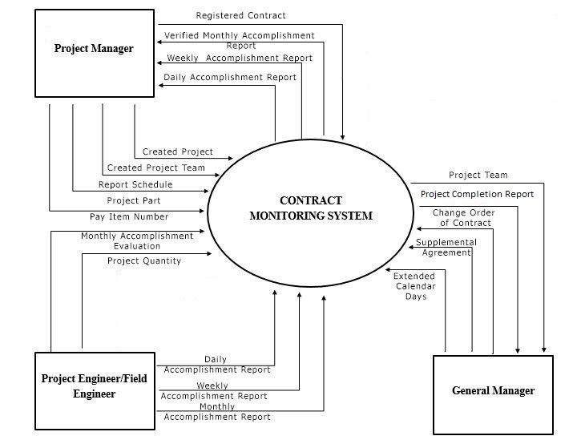**2.2.1.1 Context Diagram**

**2.2.1.2 Level 1 DFD**

**Contract Registration**

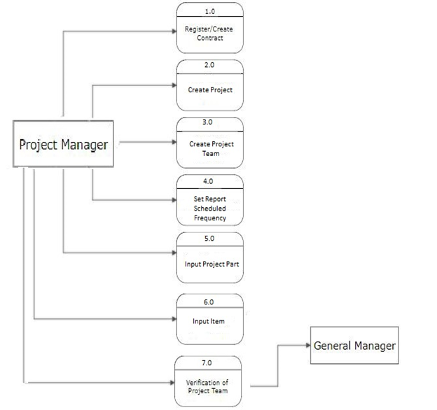

**Contract Monitoring**

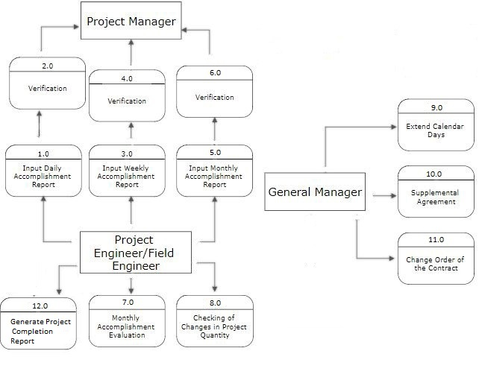

**2.2.2 Policies**

**2.2.2.1 Business Requirements**

1. In selecting project team members, a selected employee must not be selected in the other project roles. The assigned personnel selected is already pledged to the contract.
2. The relationship of contract and project is one-to-one approach. For every one contract, there is a corresponding project for it.

3. The reports prepared by the project engineer/field engineer must be verified by project manager.

**2.2.2.2 Business Policies**

**Project Implementation Process**

1. The contractor must review the project specifications.
2. The contractor must prepare Monthly Work Schedule to determine activities including the materials, equipment and manpower required.
3. Execute project based on the contract or project specifications.
4. Record daily project accomplishments in the Daily Accomplishment Report.
5. Monitor actual accomplishment using the Daily Accomplishment Report and Monthly Accomplishment Report Evaluation forms to determine if planned actions were executed as scheduled and within the agreed in-house budget.
6. Monitor implementation of the project based on the Project Specifications/Plan/S-Curve, or as defined by customers.
7. If there is a change order in program of work whether addition or deduction, the original item must be replaced to a new item of work. This will result to a new budget cost. It may be lower or greater than the original budget cost but it must not exceed up to 30%. If the budget cost exceeds 30%, a supplemental contract will be prepared. This will also affect the calendar days of the construction.
8. Submit all needed reports to the customer as scheduled, using the forms they have provided.

**Project Completion Turn over Process**

1. Inspect completed project and verify against the Project Plan/Drawing Specifications
2. Evaluate project readiness based from the Monthly Accomplishment Report Evaluation and the results of project monitoring.
3. Accomplish the Project Completion Report to evaluate execution of the project.

**2.3 Problem Analysis**

* + 1. 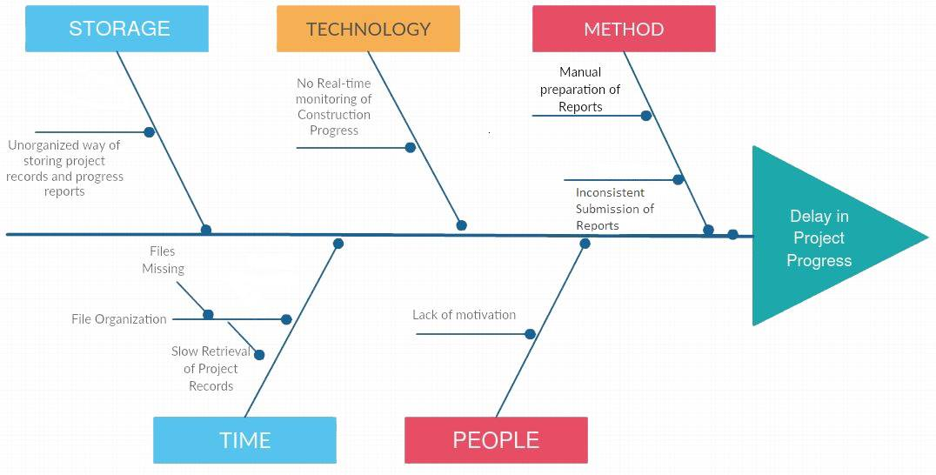**Fishbone Diagram**
    2. **Problems and Requirements**

|  |  |  |  |
| --- | --- | --- | --- |
| **Ref. Page** | **No.** | **Problems** | **Requirements** |
| **13** | **1** | Manual preparation of progress reports | Computer-based preparation of reports |
| **13** | **2** | Inconsistent submission of reports | Consistent submission of reports based on frequency |
| **13** | **3** | Unorganized way of storing project records and progress reports | Database that could handle data and data relationships |
| **13** | **4** | Slow retrieval of project records | Fast and optimized data storage for retrieval of project records |
| **13** | **5** | Lack of motivation | A solution that will monitor the task of the project. |
| **13** | **6** | No Real-time monitoring of Construction Progress | A technique that allows the company to determine the current state of the project |

**2.3.3 Conclusion**

The success of the monitoring system is subjected to various management factors in particularly, the determination of the management to have a well-organized contract monitoring. The construction industry has its generic and organic nature so that a delicate contract monitoring system is needed to improve their progress monitoring and service quality. It will also improve the company’s productivity since they can save time and effort in monitoring the projects during the process.

**2.3.4 Recommendation**

The following recommendations are offered for related research in the field of technology.

1. The Contract Monitoring System needs proper maintenance. It is also advised to read the Procedures Manual provided and train the users on proper way of using it.
2. The researchers recommends this project system to the contractors to monitor their project progress and easier management of data.

**Chapter III**

**Proposed System Definition**

* 1. **Requirements- Features Matrix-Traceability Matrix**

|  |  |  |  |  |  |  |
| --- | --- | --- | --- | --- | --- | --- |
| **Requirements**  **Features** | **REQ 1:** Computer-based preparation of reports | **REQ 2:** Consistent submission of reports based on frequency | **REQ 3:** Database that could handle data and data relationships | **REQ 4:** Fast and optimized data storage for retrieval of project records | **REQ 5:** A solution that will monitor the task of the project | **REQ 6:** A technique that allows the company to determine the current state of the project |
| **Feat 1:** The system provides a contract registration and project creation |  |  | **✓** | **✓** |  |  |
| **Feat 2:** The system features a real-time monitoring of construction progress through project part and item quantity accomplishment | **✓** | **✓** |  |  | **✓** | **✓** |
| **Feat 3:** The system ensures project records are well-organized |  |  | **✓** | **✓** |  | **✓** |
| **Feat 4:** The system notifies the end user if a report has been submitted on the frequency that has been set |  | **✓** |  |  | **✓** |  |
| **Feat 5:** The system provides an evaluation of the construction progress through the expected and actual line graph of the project. |  |  |  |  | **✓** | **✓** |

**3.2 Functional Specification**

**3.2.1 System Boundaries**

**3.2.1.1 System Use Case Diagram**

**Contract Monitoring System**



Project Manager



General Manager

Project Engineer/Field Engineer

* + - 1. 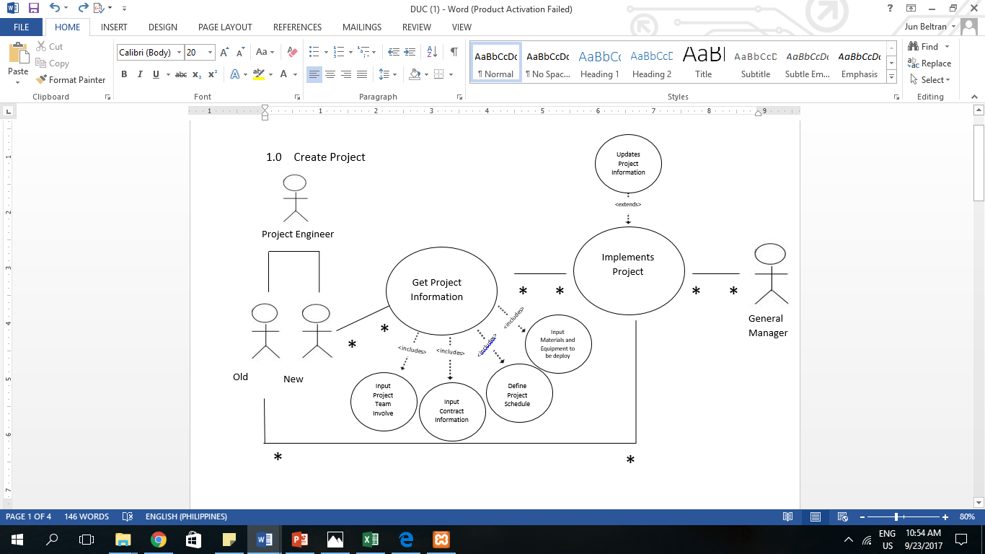**Detailed Use Case Diagram**

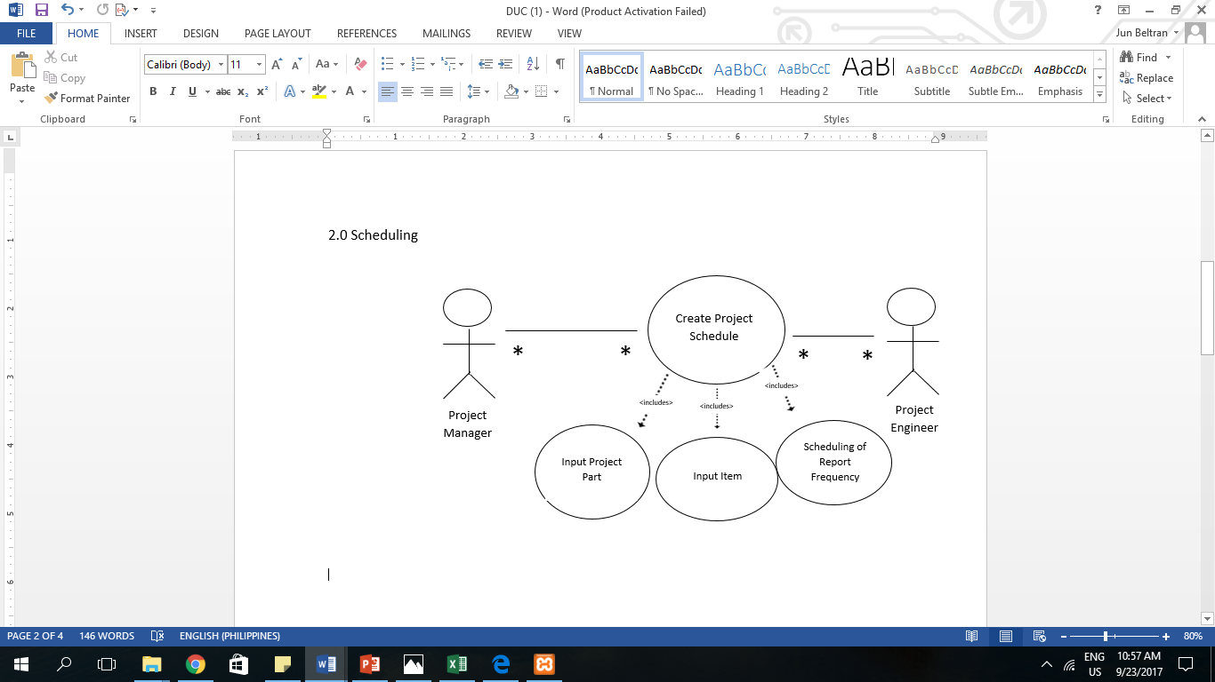

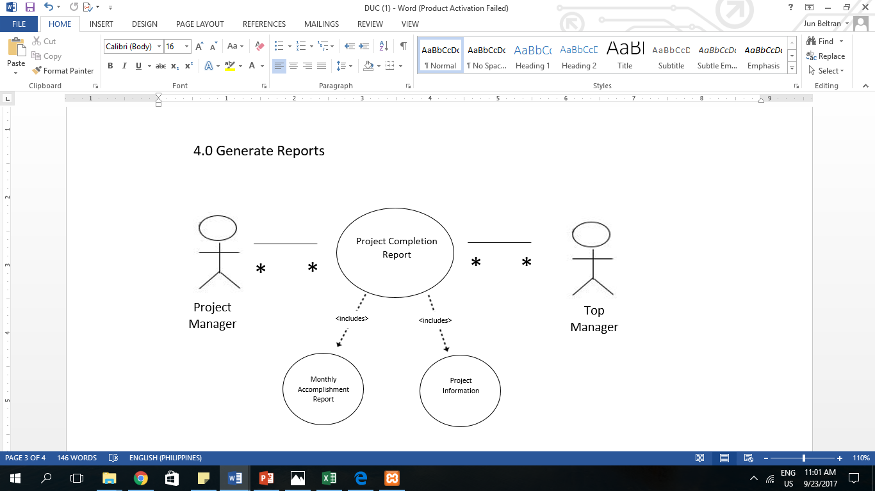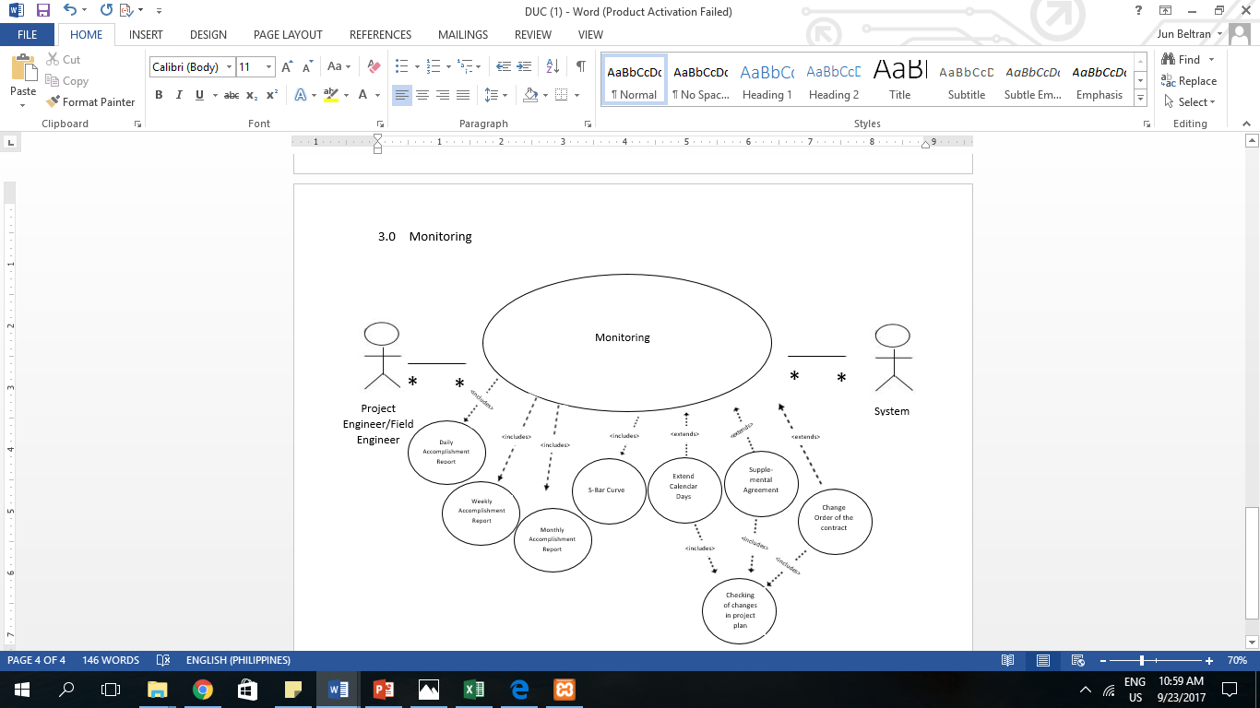

**3.2.1.3 Use Case Description**

|  |  |  |  |  |
| --- | --- | --- | --- | --- |
| **Use Case Name** | Create Project | Scheduling | Monitoring | Generate Reports |
| **Actors** | Project Manager, General Manager | Project Manager, General Manager | Project Engineer/Field Engineer , Project Manager | General Manager |
| **Purpose** | To create a new project contract. | To create a project schedule and for the scheduling of report frequency. | To monitor the daily, weekly and monthly accomplishment report and also for checking of changes in project plan. | To generate the project completion report. |
| **Brief Description** | Creating a project for the new transaction. | Managing the calendar, agendas and arrange appointments. | Regular observation and recording of activities in a project. | To produce needed documents or report. |
| **Pure Condition** | Input Project Team Involve, Input Contract Information, Define Project Schedule (input part & item), Input Materials & Equipment to be deploy | Input Project Part , Input Item, Scheduling of Report Frequency | Project Schedule, Daily, Weekly and Monthly Accomplishment Report, Checking of Changes in Project Plan | Monthly Accomplishment Report, Project Information |
| **Post Condition** | Updates Project Information |  | Extend Calendar Days, Supplemental Agreement, Change Order of the Contract |  |

**3.3 Technical Specification**

**3.3.1 Class Diagram**

**3.3.1.1 List of Classes**

|  |  |
| --- | --- |
| **Table Name** | **Description** |
| Actions | This table contains information about the actions taken in the monthly accomplishment report. |
| Activities | This table contains information about the activities for the month. |
| Audit | This table contains the log information of the system |
| Category | This table contains information about the resources’ |
| Client | This table contains information about the company’s clients. |
| Consultant | This table contains information about the consultants |
| Contract | This table contains information about the contracts taken by the company. |
| Dailyacco | This table contains information about the data needed for the daily accomplishment report. |
| Documents | This table contains information about the documents received by the company regarding the progress of the project. |
| Employee | This table contains information about the company’s employees. |
| Eqptreq | This table contains information about the equipment required for the monthly work schedule. |
| Equipment | This table contains information about the companies’ equipment. |
| Labor | This table contains information about the companies’ manpower. |
| Laborreq | This table contains information about the manpower required for the monthly work schedule. |
| Majoract | This table contains information about the major activities to be done next month. |
| Materials | This table contains information about the companies’ materials. |
| Matreq | This table contains information about the materials required for the monthly work schedule. |
| Monthlyacco | This table contains information about the information needed for the monthly accomplishment report. |
| Monthlysched | This table contains information about the information needed for the monthly work schedule form. |
| Photos | This table contains information about the photos uploaded to the system. |
| Problems | This table contains information about the problems encountered during the duration of the contract. |
| Project | This table contains information about the project. |
| Received | This table contains information about the received resources that is needed for the daily accomplishment report. |
| Receiveddocu | This table contains information about the received documents that is needed for the daily accomplishment report. |
| Receivedeqpt | This table contains information about the equipment received that is needed for the daily accomplishment report. |
| Receivedmat | This table contains information about the materials received that is needed for the daily accomplishment report. |
| Reports | This table contains information about the reports. |
| Scope | This table contains information about the scope of the project. |
| Subcategories | This table contains information about the subcategories of the equipment. |
| Subcontractor | This table contains information about the subcontractors of the company. |
| User | This table contains information about users who have access to the system. |
| Visitors | This table contains information about the visitors who went to the site that is needed for the daily accomplishment report. |
| Workacco | This table contains information about the information needed for the monthly accomplishment report. |

**3.3.1.2 Class Diagrams (ERD)**

**3.3.2 Activity Diagram**

|  |  |  |  |  |
| --- | --- | --- | --- | --- |
| 1.0 Create Project | | | | |
| Project Manager | Project Engineer/Field Engineer | General Manager | Top Manager | Table Name |
| Create Project  Input Project Team  Register Contract |  | Verification of Project Team |  |  |

|  |  |  |  |  |
| --- | --- | --- | --- | --- |
| 2.0 Scheduling | | | | |
| Project Manager | Project Engineer/Field Engineer | General Manager | Top Manager | Table Name |
| Input Project Part  Input Item |  |  |  |  |

|  |  |  |  |  |
| --- | --- | --- | --- | --- |
| 3.0 Monitoring | | | | |
| Project Manager | Project Engineer/Field Engineer | General Manager | Top Manager | Table Name |
|  | NO  YES  Input Daily Accomplishment Report  Verify |  |  |  |

**\***same process with weekly and monthly

|  |  |  |  |  |
| --- | --- | --- | --- | --- |
| 4.0 Generate Reports | | | | |
| Project Manager | Project Engineer/Field Engineer | General Manager | Top Manager | Table Name |
|  | Generate Project Completion Report |  | Review  If ok?  NO  YES |  |

**3.3.3 Database Design**

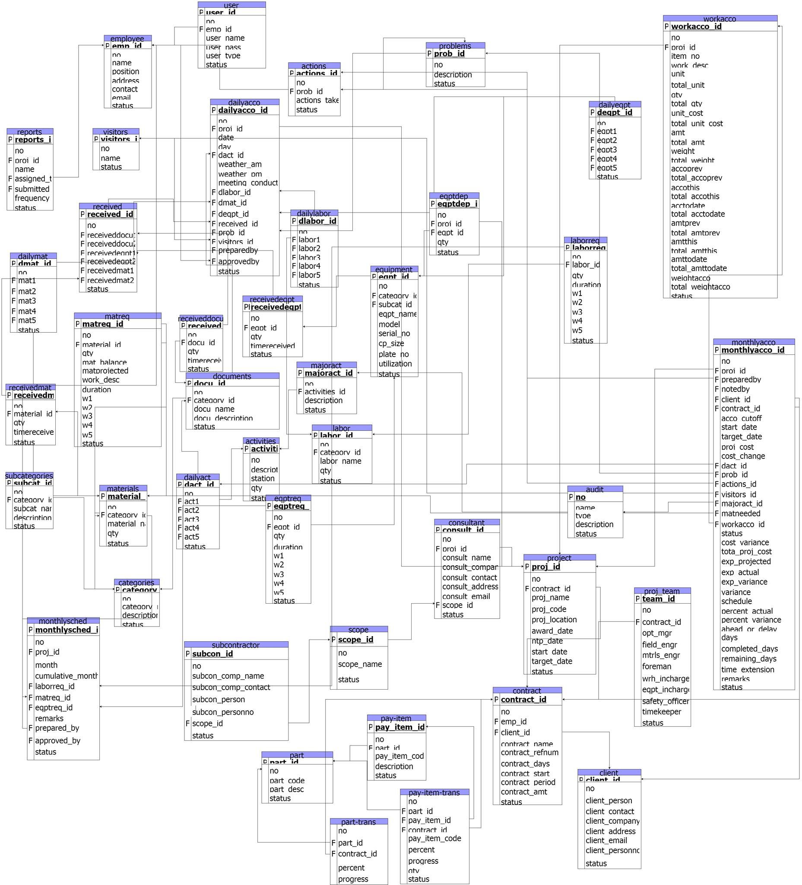**3.3.3.1 Database Schema**

**3.3.3.2 Data Dictionary**

Table Name: ACTIONS

|  |  |  |  |
| --- | --- | --- | --- |
| **Field Name** | **Field Type** | **Field Size** | **Sample** |
| No | Int | 4 | 0001 |
| Actions_id | Varchar | 50 | ANS-001 |
| Action_taken | Varchar | 50 | Excavation |
| Status | Enum(‘Active’,’Inactive’) |  | Active |

Table Name: ACTIVITIES

|  |  |  |  |
| --- | --- | --- | --- |
| **Field Name** | **Field Type** | **Field Size** | **Sample** |
| No | Int | 4 | 0001 |
| Activities_id | Varchar | 20 | ACT-001 |
| Description | Varchar | 255 | Waterworks |
| Station | Varchar | 50 | K0495 + 024 |
| Qty | Int | 11 | 5 |
| status | Enum(‘Active’,’Inactive’) |  | Active |

Table Name: AUDIT

|  |  |  |  |
| --- | --- | --- | --- |
| **Field Name** | **Field Type** | **Field Size** | **Sample** |
| No | Int | 11 | 0080 |
| Type | Enum(‘INSERT’,’UPDATE’,’DELETE’) |  | Update |
| Name | Varchar | 100 | Eunice Beltran |
| description | Varchar | 255 | Updated client company: Lalalaaaand --> blank |
| Timestamp | Timestamp |  | 2017-09-16 16:25:58 |
| Status | Enum(‘Active’,’Inactive’) |  | Active |

Table Name: CATEGORY

|  |  |  |  |
| --- | --- | --- | --- |
| **Field Name** | **Field Type** | **Field Size** | **Sample** |
| No | Int | 4 | 0001 |
| Category_id | Varchar | 50 | CAT-629 |
| Category_name | varchar | 255 | Foreman |
| Description | Varchar | 50 | Labor |
| Status | Enum(‘Active’,’Inactive’) |  | Active |

Table Name: CLIENT

|  |  |  |  |
| --- | --- | --- | --- |
| **Field Name** | **Field Type** | **Field Size** | **Sample** |
| No | Int | 4 | 0003 |
| Client_id | varchar | 20 | CLI-0003 |
| Client_person | Varchar | 100 | Celeena |
| Client_personno | Char | 11 | 09157161253 |
| Client_company | Varchar | 100 | Sufferland |
| Client_contact | Char | 11 | 09876543210 |
| Client_address | varchar | 255 | Mandaluyong City |
| Client_email | varchar | 50 | [lala@yahoo.com](mailto:lala@yahoo.com) |
| Status | Enum(‘Active’,’Inactive’) |  | Inactive |

Table Name: CONSULTANT

|  |  |  |  |
| --- | --- | --- | --- |
| **Field Name** | **Field Type** | **Field Size** | **Sample** |
| No | Int | 4 | 0001 |
| Consult_id | Varchar | 20 | CST-0001 |
| Proj_id | Varchar | 100 | PRJ-0001 |
| Consult_name | Varchar | 255 | Derullo |
| Consult_company | Varchar | 255 | Red Box |
| Consult_contact | char | 11 | 283-6373 |
| Consult_address | varchar | 100 | San Juan City |
| Consult_email | Varchar | 100 | redbox@gmail.com |
| Scope_id | varchar | 20 | SCO-001 |
| Status | Enum(‘Active’,’Inactive’) |  | Active |

Table Name: CONTRACT

|  |  |  |  |
| --- | --- | --- | --- |
| **Field Name** | **Field Type** | **Field Size** | **Sample** |
| No | Int | 4 | 8334 |
| Contract_id | Varchar | 20 | CON-0001 |
| Emp_id | Varchar | 50 | EMP-5671 |
| Client_id | Varchar | 20 | CLI-0749 |
| Contract_name | Varchar | 255 | Const. of Drainage Along F. Blumentritt |
| Contract_refnum | Varchar | 50 | 111222333 |
| Contract_days | Int | 11 | 300 |
| Contract_start | Date |  | 2017-09-20 |
| Contract_period | Date |  | 2017-09-30 |
| Contract_amt | decimal | 30,2 | 1054232.25 |
| Status | Enum(‘Active’,’Inactive’) |  | Active |

Table Name: DAILYACCO

|  |  |  |  |
| --- | --- | --- | --- |
| **Field Name** | **Field Type** | **Field Size** | **Sample** |
| No | Int | 4 | 0001 |
| Dailyacco_id | varchar | 20 | DAI-6298 |
| Proj_id | Varchar | 100 | PRJ-0001 |
| Date | Datetime |  | 2017-09-21 |
| Day | Enum(‘Monday’,’Tuesday’,  ‘Wednesday’, ‘Thursday’,  ‘Friday’,’Saturday’,’Sunday’) |  | Monday |
| Activities_id | varchar | 100 | ACT-4823 |
| Weather_am | Varchar | 50 | Sunny |
| Weather_pm | Varchar | 50 | Cloudy |
| Meeting_conducted | Enum(‘YES’,’NO’) |  | Yes |
| Dlabor_id | Varchar | 50 | DLA-5373 |
| Dmat_id | Varchar | 50 | DMA-5523 |
| Deqpt_id | Varchar | 50 | DEQ-0093 |
| Receive_id | varchar | 100 | REC-6384 |
| Prob_id | Varchar | 100 | PRO-7734 |
| Visitors_id | Varchar | 100 | VIS-2626 |
| Prepared_by | Varchar | 100 | Celeena |
| Approved_by | Varchar | 100 | Chester |
| Status | Enum(‘Active’,’Inactive’) |  | Active |

Table Name: DOCUMENTS

|  |  |  |  |
| --- | --- | --- | --- |
| **Field Name** | **Field Type** | **Field Size** | **Sample** |
| No | Int | 4 | 0001 |
| Docu_id | Varchar | 20 | DOC-0001 |
| Category_id | Varchar | 20 | CAT-6272 |
| Docu_name | Varchar | 100 | Stamp |
| Docu_description | Varchar | 255 | Record |
| Status | Enum(‘Active’,’Inactive’) |  | Inactive |

Table Name: EMPLOYEE

|  |  |  |  |
| --- | --- | --- | --- |
| **Field Name** | **Field Type** | **Field Size** | **Sample** |
| No | Int | 4 | 0001 |
| Emp_id | Varchar | 100 | EMP-7732 |
| Name | Varchar | 100 | Georgie |
| Position | Varchar | 100 | President |
| Address | Varchar | 100 | Malinta |
| Contact | Char | 11 | 263-8345 |
| Email | Varchar | 50 | georgie@gmail.com |
| Status | Enum(‘Active’,’Inactive’) |  | Active |

Table Name: EQPTREQ

|  |  |  |  |
| --- | --- | --- | --- |
| **Field Name** | **Field Type** | **Field Size** | **Sample** |
| No | Int | 4 | 0001 |
| Eqptreq_id | Varchar | 20 | EQR-0001 |
| Eqpt_id | Varchar | 100 | EQP-0001 |
| Qty | Int | 11 | 25 |
| Duration | Datetime |  | 2017-09-25 |
| W1 | Int | 11 | 5 |
| W2 | Int | 11 | 5 |
| W3 | Int | 11 | 5 |
| W4 | Int | 11 | 5 |
| W5 | Int | 11 | 5 |
| Status | Enum(‘Active’,’Inactive’) |  | Inactive |

Table Name: EQUIPMENT

|  |  |  |  |
| --- | --- | --- | --- |
| **Field Name** | **Field Type** | **Field Size** | **Sample** |
| No | Int | 4 | 0001 |
| Eqpt_id | varchar | 50 | EQP-0001 |
| Category_id | Varchar | 50 | CAT-0001 |
| Subcat_id | Varchar | 50 | SUB-0001 |
| Eqpt_name | Varchar | 255 | Balisong |
| Status | Enum(‘Active’,’Inactive’) |  | Active |

Table Name: LABOR

|  |  |  |  |
| --- | --- | --- | --- |
| **Field Name** | **Field Type** | **Field Size** | **Sample** |
| No | Int | 4 | 2739 |
| Labor_id | Varchar | 50 | LAB-7282 |
| Category_id | Varchar | 50 | CAT-8830 |
| Labor_name | varchar | 255 | Barny |
| Qty | Int | 11 | 5 |
| Status | Enum(‘Active’,’Inactive’) |  | Active |

Table Name: LABORREQ

|  |  |  |  |
| --- | --- | --- | --- |
| **Field Name** | **Field Type** | **Field Size** | **Sample** |
| No | Int | 4 | 8893 |
| Laborreq_id | Varchar | 20 | LABR-56783 |
| Labor_id | Varchar | 100 | LAB-98342 |
| Qty | Int | 11 | 45 |
| Duration | Datetime |  | 2018-03-18 |
| W1 | Int | 11 | 232 |
| W2 | Int | 11 | 12 |
| W3 | Int | 11 | 2 |
| W4 | Int | 11 | 3 |
| W5 | Int | 11 | 4 |
| Status | Enum(‘Active’,’Inactive’) |  | Inactive |

Table Name: MAJORACT

|  |  |  |  |
| --- | --- | --- | --- |
| **Field Name** | **Field Type** | **Field Size** | **Sample** |
| No | Int | 4 | 1239 |
| Majoract_id | Varchar | 20 | MAJ-8829 |
| Activities_id | Varchar | 255 | ACT-8273 |
| Description | Varchar | 255 | PCCP |
| Status | Enum(‘Active’,’Inactive’) |  | Active |

Table Name: MATERIALS

|  |  |  |  |
| --- | --- | --- | --- |
| **Field Name** | **Field Type** | **Field Size** | **Sample** |
| No | Int | 4 | 0001 |
| Material_id | Varchar | 50 | MAT-0001 |
| Category_id | Varchar | 50 | CAT-0001 |
| Material_name | Varchar | 255 | Portland |
| Qty | Int | 11 | 50 |
| Status | Enum(‘Active’,’Inactive’) |  | Active |

Table Name: MATREQ

|  |  |  |  |
| --- | --- | --- | --- |
| **Field Name** | **Field Type** | **Field Size** | **Sample** |
| No | Int | 4 | 0001 |
| Matreq_id | varchar | 20 | MTR-0001 |
| Material_id | varchar | 100 | MAT-0001 |
| Mat_balance | Int | 11 | 0 |
| Mat_projected | Int | 11 | 50 |
| Work_desc | varchar | 255 | Pang halo |
| Duration | Int | 11 | 20 |
| W1 | Int | 11 | 10 |
| W2 | Int | 11 | 10 |
| W3 | Int | 11 | 10 |
| W4 | Int | 11 | 10 |
| W5 | Int | 11 | 10 |
| Status | Enum(‘Active’,’Inactive’) |  | Active |

Table Name: MONTHLYACCO

|  |  |  |  |
| --- | --- | --- | --- |
| **Field Name** | **Field Type** | **Field Size** | **Sample** |
| No | Int | 4 | 2273 |
| Monthlyacco_id | Varchar | 20 | MON-66383MN |
| Proj_id | Varchar | 100 | PRJ-0001 |
| Prepared_by | Varchar | 100 | Admiral |
| Noted_by | Varchar | 100 | Kenji |
| Client_id | Varchar | 100 | CLI-99282 |
| Contract_id | Varchar | 100 | CON-2663KL662 |
| Acco_cutoff | Date |  | 2068-09-09 |
| Start_date | Date |  | 2020-01-15 |
| Target_date | Date |  | 2058-08-18 |
| Proj_cost | Decimal | 30,2 | 95000650 |
| Cost_change | Decimal | 30,2 | 800000000000 |
| Cost_variance | Enum(‘ADDITION’,  ’DEDUCTION’) |  | Addition |
| Total_proj_cost | Decimal | 30,2 | 7839375967448.09 |
| Exp_projected | Decimal | 30,2 | 567890.98 |
| Exp_actual | Decimal | 30,2 | 838494.67 |
| Exp_variance | Enum(‘ADDITION’,  ’DEDUCTION’) |  | Addition |
| Variance | Decimal | 30,2 | 567833.79 |
| Schedule | Decimal | 30,2 | 231.00 |
| Percent_actual | Decimal | 30,2 | 673730.98 |
| Percent_variance | Decimal | 30,2 | 123.00 |
| Ahead_or_delay | Enum(‘AHEAD’,’DELAY’) |  | Ahead |
| Days | Int | 11 | 78904948 |
| Completed_days | Int | 11 | 300 |
| Remaining_days | Int | 11 | 78904547 |
| Time_extension | Int | 11 | 840978 |
| Activities_id | Varchar | 100 | ACT-27384HDK63JH |
| Prob_id | Varchar | 100 | PRO-UNF334NFH69 |
| Actions_id | Varchar | 100 | ACT-73SKSHFS44 |
| Majoract_id | Varchar | 100 | MAJ-663HBD825HS |
| Mmat_id | Varchar | 100 | MMA-ASDZXC |
| Remarks | Varchar | 100 | PASSWORD |
| Workacco_id | Varchar | 100 | WOR-998HDLLS877 |
| Status | Enum(‘Active’,’Inactive’) |  | Active |

Table Name: MONTHLYSCHED

|  |  |  |  |
| --- | --- | --- | --- |
| **Field Name** | **Field Type** | **Field Size** | **Sample** |
| No | Int | 4 | 8830 |
| Monthlysched_id | Varchar | 20 | MON-883JJ36H9F |
| Proj_id | Varchar | 100 | PRJ-0001 |
| Month | Enum(‘JANUARY’,  ‘FEBUARY’,‘MARCH’,  ‘APRIL’,‘MAY’,‘JUNE’,  ‘JULY’,‘AUGUST’,  ‘SEPTEMBER’,  ‘OCTOBER’,‘NOVEMBER’,  ‘DECEMBER’) |  | JUNE |
| Cumulative_month | Enum(‘JANUARY’,  ‘FEBUARY’,‘MARCH’,  ‘APRIL’,‘MAY’,‘JUNE’,  ‘JULY’,‘AUGUST’,  ‘SEPTEMBER’,  ‘OCTOBER’,‘NOVEMBER’,  ‘DECEMBER’) |  | JULY |
| Laborreq_id | Varchar | 20 | LAB-8834 |
| Eqptreq_id | Varchar | 20 | EQT-2234 |
| Remarks | Varchar | 255 | Wala |
| Prepared_by | Varchar | 100 | Me |
| Approved_by | Varchar | 100 | You |
| Status | Enum(‘Active’,’Inactive’) |  | Inactive |

Table Name: PROBLEMS

|  |  |  |  |
| --- | --- | --- | --- |
| **Field Name** | **Field Type** | **Field Size** | **Sample** |
| No | Int | 4 | 3524 |
| Prob_id | Varchar | 20 | PRO-883911 |
| Description | Varchar | 255 | Pang-linis |
| Status | Enum(‘Active’,’Inactive’) |  | Active |

Table Name: PROJECT

|  |  |  |  |
| --- | --- | --- | --- |
| **Field Name** | **Field Type** | **Field Size** | **Sample** |
| No | Int | 4 | 0001 |
| Proj_id | Varchar | 20 | PRJ-0001 |
| Contract_id | Varchar | 100 | CON-0001 |
| Proj_name | Varchar | 255 | Const. of Drainage along F. Blumentritt, San Juan |
| Proj_code | Varchar | 255 | Drainage-Blumentritt-SJ |
| Proj_location | Varchar | 255 | San Juan City |
| Award_date | Date |  | 2017-09-21 |
| Ntp_date | Date |  | 2017-09-25 |
| Start_date | Date |  | 2017-10-01 |
| Target_date | Date |  | 2018-03-11 |
| Status | Enum(‘Active’,’Inactive’) |  | Active |

Table Name: RECEIVED

|  |  |  |  |
| --- | --- | --- | --- |
| **Field Name** | **Field Type** | **Field Size** | **Sample** |
| No | Int | 4 | 0001 |
| Received_id | Varchar | 20 | RCD-0001 |
| Receiveddocu id | Varchar | 20 | RDC-0001 |
| Receivedeqpt_id | Varchar | 20 | RDE-0001 |
| Receivedmat_id | Varchar | 20 | RDM-0001 |
| Status | Enum(‘Active’,’Inactive’) |  | Active |

Table Name: RECEIVEDDOCU

|  |  |  |  |
| --- | --- | --- | --- |
| **Field Name** | **Field Type** | **Field Size** | **Sample** |
| No | Int | 4 | 0001 |
| Receiveddocu_id | Varchar | 20 | RDC-0001 |
| Docu_id | Varchar | 100 | DOC-0001 |
| Qty | Int | 11 | 1873 |
| Timereceived | timestamp |  | 2017-09-16 15:36:40 |
| Status | Enum(‘Active’,’Inactive’) |  | Inactive |

Table Name: RECEIVEDEQPT

|  |  |  |  |
| --- | --- | --- | --- |
| **Field Name** | **Field Type** | **Field Size** | **Sample** |
| No | Int | 4 | 0001 |
| Receivedeqpt_id | Varchar | 20 | RDE-0001 |
| Eqpt_id | Varchar | 100 | EQP-0001 |
| Qty | Int | 11 | 1 |
| Timereceived | Timestamp |  | 2017-09-16 15:36:40 |
| Status | Enum(‘Active’,’Inactive’) |  | Active |

Table Name: RECEIVEDMAT

|  |  |  |  |
| --- | --- | --- | --- |
| **Field Name** | **Field Type** | **Field Size** | **Sample** |
| No | Int | 4 | 0001 |
| Receivedmat_id | Varchar | 20 | RDM-0001 |
| Material_id | Varchar | 100 | MAT-0001 |
| Qty | Int | 11 | 2 |
| Timereceived | Timestamp |  | 2017-09-16 15:36:40 |
| status | Enum(‘Active’,’Inactive’) |  | Active |

Table Name: REPORTS

|  |  |  |  |
| --- | --- | --- | --- |
| **Field Name** | **Field Type** | **Field Size** | **Sample** |
| No | Int | 4 | 0001 |
| Reports_id | Varchar | 30 | RPT-0001 |
| Proj_id | Varchar | 30 | PRJ-0001 |
| Name | Varchar | 100 | Weekly Report |
| Assigned_to | Varchar | 30 | Charlon Quiminales |
| Submitted_to | Varchar | 30 | Bernie Remollo |
| Frequency | Enum(‘DAILY’,  ‘WEEKLY’,  ‘MONTHLY’) |  | WEEKLY |
| Status | Enum(‘Active’,’Inactive’) |  | Active |

Table Name: SCOPE

|  |  |  |  |
| --- | --- | --- | --- |
| **Field Name** | **Field Type** | **Field Size** | **Sample** |
| No | Int | 4 | 0001 |
| Scope_id | Varchar | 20 | SCP-0001 |
| Scope_name | Varchar | 255 | Electrical Works |
| Status | Enum(‘Active’,’Inactive’) |  | Active |

Table Name: SUBCATEGORIES

|  |  |  |  |
| --- | --- | --- | --- |
| **Field Name** | **Field Type** | **Field Size** | **Sample** |
| No | Int | 4 | 0001 |
| Subcat_id | Varchar | 20 | SUB-0001 |
| Category_id | Varchar | 20 | CAT-0001 |
| Subcat_name | Varchar | 255 | Excavator |
| Description | Enum(‘EQUIPMENT’,  ’LABOR’,’MATERIAL’) |  | EQUIPMENT |
| status | Enum(‘Active’,’Inactive’) |  | Active |

Table Name: SUBCONTRACTOR

|  |  |  |  |
| --- | --- | --- | --- |
| **Field Name** | **Field Type** | **Field Size** | **Sample** |
| No | Int | 4 | 0001 |
| Subcon_id | Varchar | 20 | SBC-0001 |
| Subcon_comp_name | Varchar | 255 | J. Builders |
| Subcon_comp_contact | Char | 11 | 678-3404 |
| Subcon_person | Varchar | 255 | Celeena Alonzo |
| Subcon_personno | Char | 11 | 883-5672 |
| Scope_id | Varchar | 100 | SCP-0001 |
| status | Enum(‘Active’,’Inactive’) |  | Active |

Table Name: USER

|  |  |  |  |
| --- | --- | --- | --- |
| **Field Name** | **Field Type** | **Field Size** | **Sample** |
| No | Int | 11 | 0001 |
| User_id | Varchar | 30 | 7YUHJAS243 |
| Emp_id | Varchar | 100 | 5YTHW9I3SC |
| User_name | Varchar | 255 | BALIK |
| User_pass | Varchar | 50 | ESKWELA |
| User_type | Enum(‘ADMIN’,  ’TOP MANAGER’,  ’SAFETY OFFICER’,  ‘PROJECT MANAGER’,  ‘PROJECT ENGINEER’) |  | ADMIN |
| Status | Enum(‘Active’,’Inactive’) |  | ACTIVE |
| Account_status | Enum(‘Active’,’Inactive’) |  | ACTIVE |

Table Name: VISITORS

|  |  |  |  |
| --- | --- | --- | --- |
| **Field Name** | **Field Type** | **Field Size** | **Sample** |
| No | Int | 4 | 0001 |
| Visitors_id | Varchar | 20 | 8IK3R8U6578D |
| Name | Varchar | 100 | JENNY |
| Status | Enum(‘Active’,’Inactive’) |  | Inactive |

Table Name: Workacco

|  |  |  |  |
| --- | --- | --- | --- |
| **Field Name** | **Field Type** | **Field Size** | **Sample** |
| No | Int | 4 | 0001 |
| Workacco_id | Varchar | 20 | 7IUHKJ43RE |
| Proj_id | Varchar | 20 | PRJ-0001 |
| Item_no | Int | 10 | 234-SHD533 |
| Work_desc | Varchar | 255 | SLEEPING LANG |
| Unit | Int | 11 | 67 |
| Total_unit | Int | 11 | 98 |
| Qty | Int | 11 | 100 |
| Total_qty | Int | 11 | 100 |
| Unit_cost | Decimal | 30,2 | 6500038484.87 |
| Total_unitcost | Decimal | 30,2 | 5067890449.99 |
| Amt | Decimal | 30,2 | 48838487494.92 |
| Total_amt | Decimal | 30,2 | 49929923335.12 |
| Weight | Decimal | 30,2 | 567349874.73 |
| Total_weight | Decimal | 30,2 | 78294405966.84 |
| Accoprev | Int | 11 | 5678993 |
| Total_accoprev | Int | 11 | 2344673 |
| Accothis | Int | 11 | 9078463 |
| Total_accothis | Int | 11 | 7172930 |
| Accotodate | Int | 11 | 6267389491 |
| Total_accotodate | Int | 11 | 9826740911 |
| Amtprev | Decimal | 30,2 | 6237651235123.53 |
| Total_amtprev | Decimal | 30,2 | 6512637132423.67 |
| Amtthis | Decimal | 30,2 | 1234538292222.25 |
| Total_amtthis | Decimal | 30,2 | 8726391123433.18 |
| Amttodate | Decimal | 30,2 | 76151762389398.09 |
| Total_amttodate | Decimal | 30,2 | 12365412398324.96 |
| Weightacco | Decimal | 30,2 | 54156237273239.44 |
| Total_weightacco | Decimal | 30,2 | 421563723892983.92 |
| Status | Enum(‘Active’,’Inactive’) |  | ACTIVE |

**Appendices:**

**Sample of Forms**

1. **Project Information Sheet**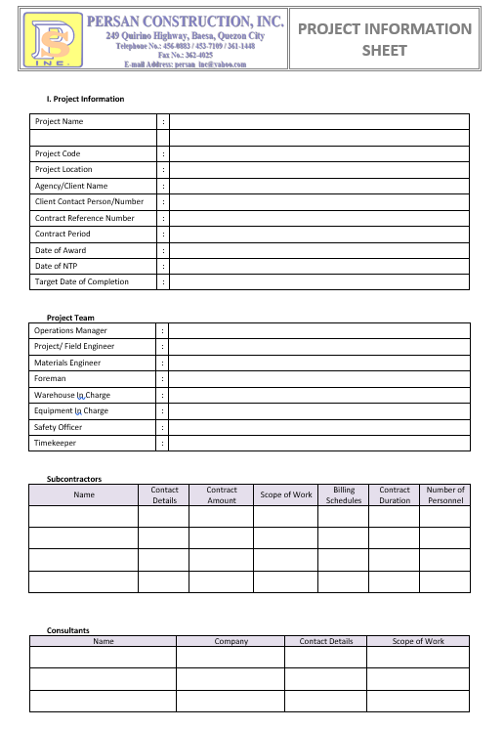

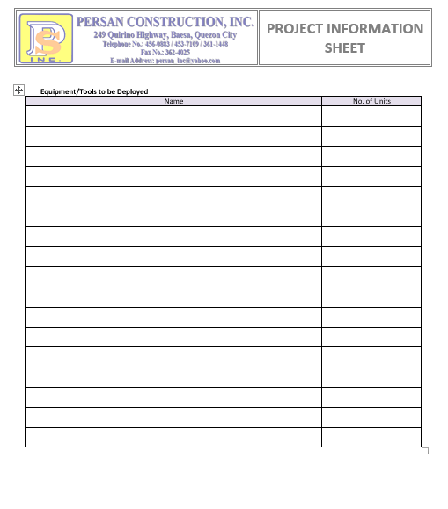



1. **Monthly Work Schedule**

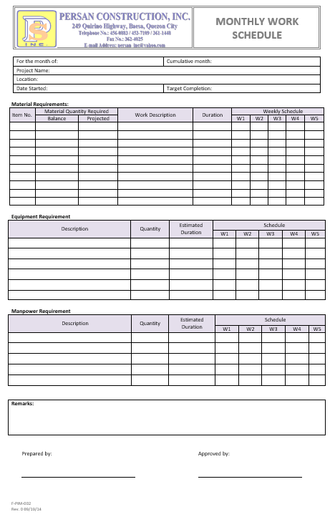

**Sample of Reports**

1. 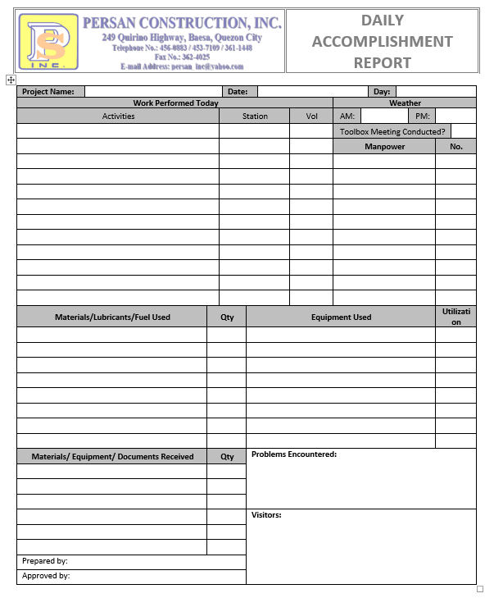**Daily Accomplishment Report**
2. 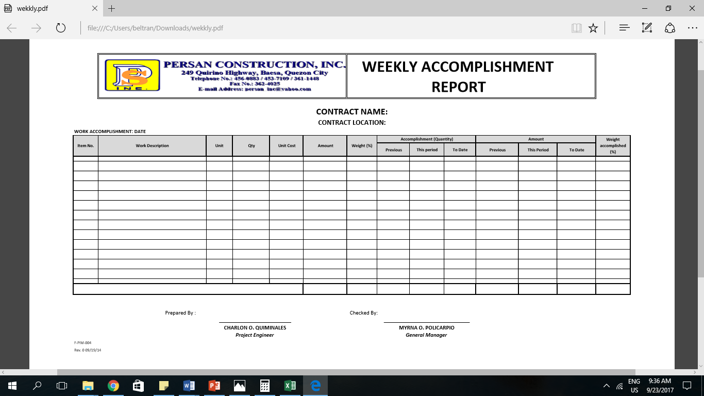**Weekly Accomplishment Report**
3. **Monthly Accomplishment Report**

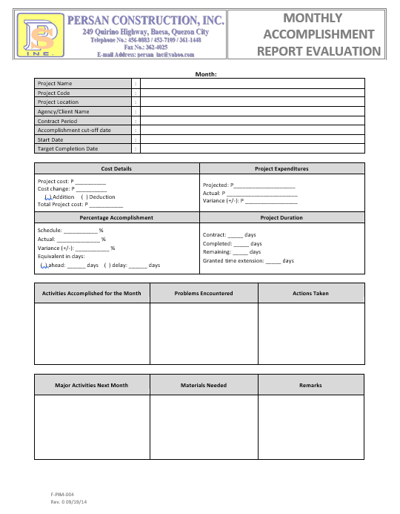

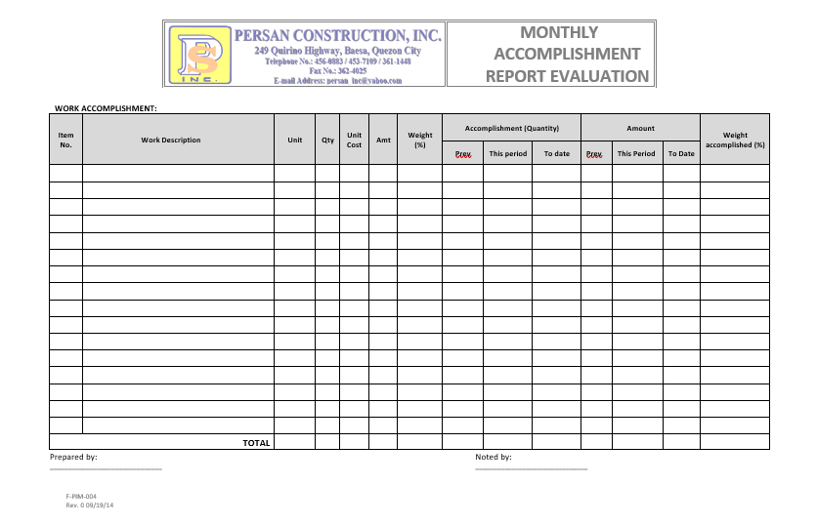

1. **Project Completion Report**

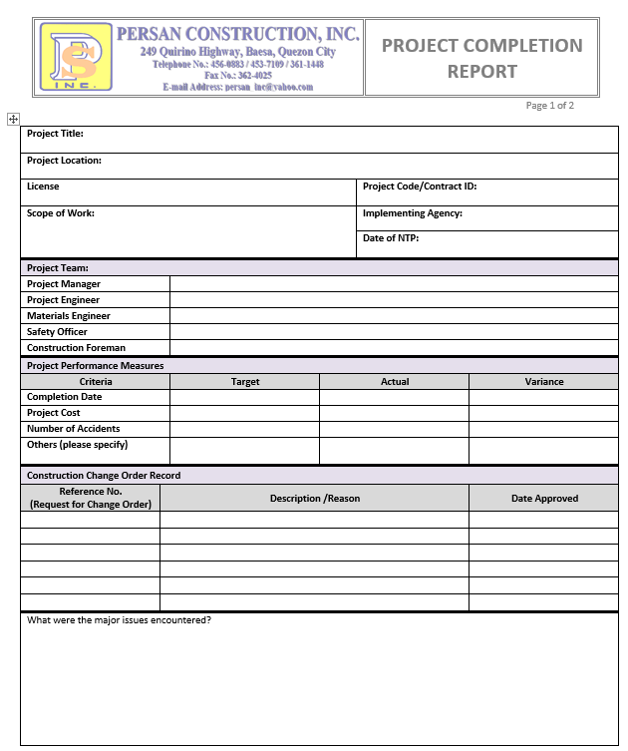

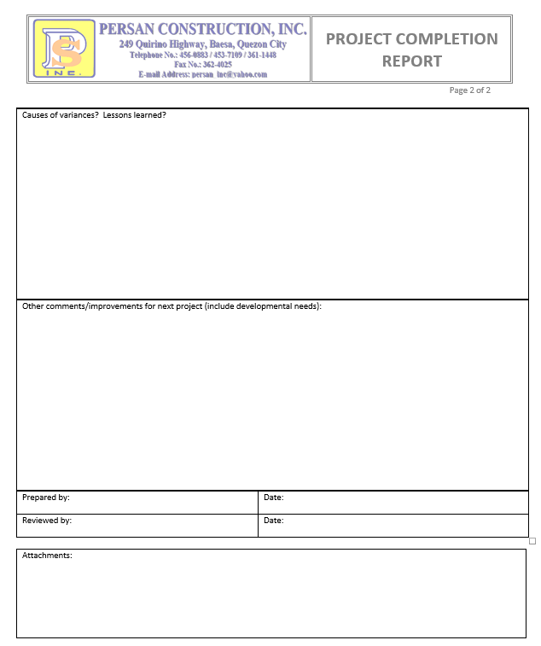

**Questionnaire**

**Likert Scale**

|  |  |
| --- | --- |
| **SCALE** | **INDICATORS** |
| 5 | EXCELLENT |
| 4 | GOOD |
| 3 | SATISFACTORY |
| 2 | NEEDS IMPROVEMENT |
| 1 | VERY POOR |

**Questionnaire**

|  |  |  |  |  |  |
| --- | --- | --- | --- | --- | --- |
| **INDICATORS** | **RATINGS** | | | | |
| **5** | **4** | **3** | **2** | **1** |
| How easy do find it to use the system? |  |  |  |  |  |
| Rate the overall Quality of the system. |  |  |  |  |  |
| How quickly was the process (checking the progress of the construction project) |  |  |  |  |  |
| How secure is the system? |  |  |  |  |  |
| Based on your experience, how likely would you recommend the system to your colleagues? |  |  |  |  |  |
| Graphic User Interface of the system |  |  |  |  |  |
| Considering the time, effort and money you spent, how would you rate the overall value provided. |  |  |  |  |  |

1. Was your issue resolved using our system?

YES

NO

1. Were we knowledgeable and helpful?

YES

NO

1. Were you served quickly?

YES

NO

1. Did we met your expectations?

YES

NO

1. Is the system user friendly?

YES

NO

Do you have other suggestions to improve the system?

___________________________________________________________

___________________________________________________________

Is there anything you’d like to add?

­___________________________________________________________

______________________________________________________­­­­­­_____